Phenomena of PMU Estimation Error under different Input

# Steady state

## Frequency Range

### Magnitude Error

#### Voltage

The voltage magnitude error is nearly a fixed value when the frequency deviation , i.e., When the frequency deviation is unequal to 0, it is a cosine signal, and its frequency is proportional to .

Figure 1‑1 Voltage magnitude error upon different input frequency

For phase B and C, the magnitude error follows the same rule as phase A, except that there is a phase angle difference in the cosine signal.

The voltage magnitude error can then be described as

Where

Here is dependent on , and the relation is shown in Figure 1‑2.

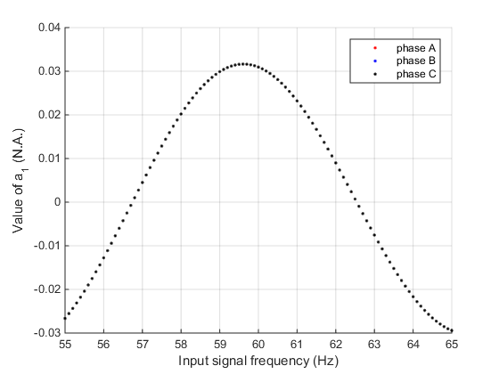

Figure 1‑2 The value vs. different input frequencies

They can be fitted using a cosine curve:

The fitting result can be shown in Figure 1‑3. The fitting is accurate in the middle part and the error increases when the frequency departs from the nominal frequency. It should be noted that the maximum value of the fitted curve reached at the frequency of 56.7 Hz rather than 60 Hz, the nominal frequency.

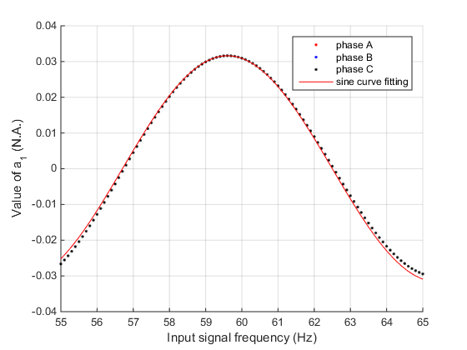

Figure 1‑3 Fitting of value using cosine curve

is also dependent on , and its relationship can be shown in Figure 1‑4.

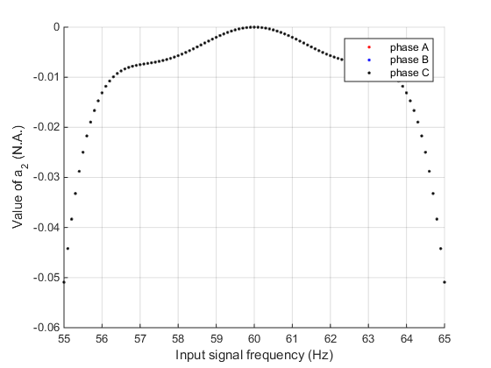

Figure 1‑4 The value vs. different input frequencies

The values of are less than 0 except for phase A when .

The change of is from the filter. Due to the filter without compensation for M class, the frequency component away from the nominal frequency is depressed after passing the filter. Therefore the magnitude of 55 Hz reached the estimation algorithm will be smaller than 60 Hz, and it shows a larger magnitude error shift, i.e. . Therefore, can be described by the spectrum character of this filter.

Filter parameters can be obtained from Annex of Standard C37.118, and its frequency response is demonstrated below. The details of the filter are illustrated in Appendix B. It can be seen from Figure 1‑5 that it fits well using the equations below.

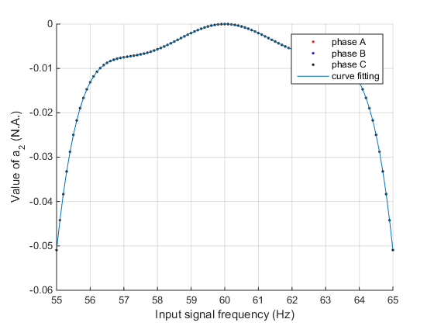

Figure 1‑5 The fitting of using the magnitude response of the filter

Now look at the initial phase angle . The values are shown in Figure 1‑6.

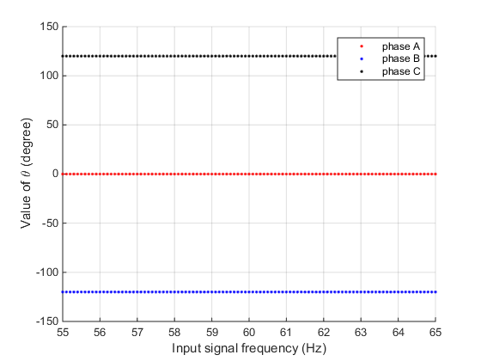

Figure 1‑6 The value vs. different input frequencies

It can be seen that they are equal to their phase angles of the input signal.

In this way, the magnitude error of voltage measurement in the frequency variation test can be decided.

#### Current

The behavior of current magnitude error is very similar to voltage, except with different values. Some plots of phase A can be seen in Figure 1‑7.

Figure 1‑7 Current magnitude error upon different input frequency

For phase B and C, the magnitude error follows the same rule as phase A, except that there is a phase angle difference in the cosine signal.

The current magnitude error can then be described as

Where

Here is dependent on . The relation and the sine curve fitting are shown in Figure 1‑8.

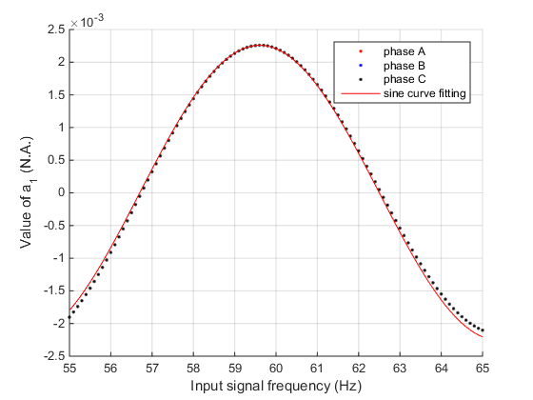

Figure 1‑8 Fitting of value using cosine curve

Besides the point at , the other points can be fitted using a cosine curve:

The fitting is accurate in the middle part and the error increases when the frequency departs from the nominal frequency. It should be noted that the maximum value of the fitted curve reached at the frequency of 56.7 Hz rather than 60 Hz, the nominal frequency.

is also dependent on , and its relationship can be shown in Figure 1‑9.

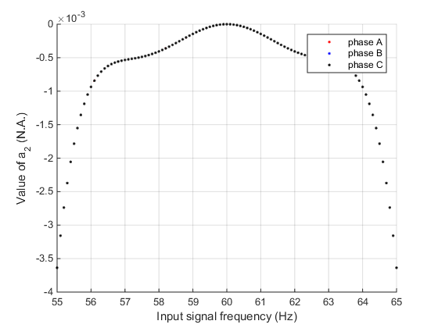

Figure 1‑9 The value vs. different input frequencies

The value of are less than 0 except for phase A when .

The change of is from the filter. Due to the filter without compensation for M class, the frequency component away from the nominal frequency is depressed after passing the filter. Therefore the magnitude of 55 Hz reached the estimation algorithm will be smaller than 60 Hz, and it shows a larger magnitude error shift, i.e. . Therefore, can be described by the spectrum character of this filter.

Filter parameters can be obtained from Annex of Standard C37.118, and its frequency response is demonstrated below. The details of the filter are illustrated in Appendix B. It can be seen from Figure 1‑10 that it fits well using the equations below.

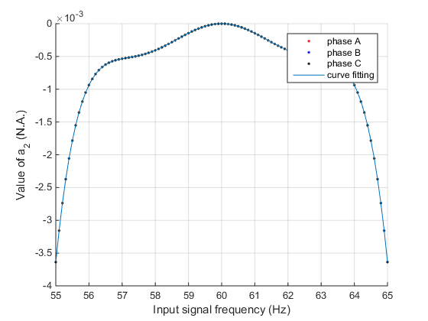

Figure 1‑10 The fitting of using the magnitude response of the filter

The initial phase angle of current is the same as voltage, shown in Figure 1‑11.



Figure 1‑11 The value vs. different input frequencies

In this way, the magnitude error of current measurement in the frequency variation test can be decided.

For both voltage and current, the magnitude error can be written as

Here is the frequency of input signal. is the nominal effective value of input magnitude, is the initial phase angle of the input signal. Usually for phase A, B, and C, respectively.

Deep investigation reveals that the does not simply follow . Input multiple different initial phase angle , it is found that the equation should be

The example of is shown in Figure 1‑12. However, when , there is .

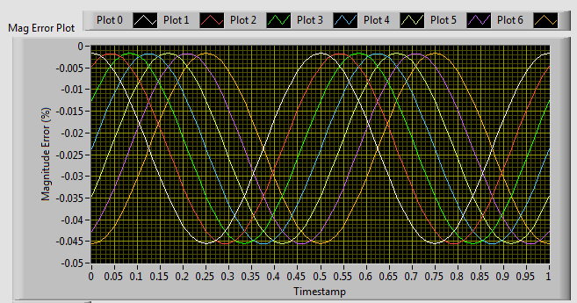

Figure 1‑12Magnitude error behavior of frequency range test when is changing from (Plot 0) (Plot 1), to (Plot 6).

### Phase Error

The voltage and current phase errors are almost the same on corresponding points; therefore, we do not divide them apart here.

Compared to the magnitude error, the phase error is more complicated. Its tendency is like the magnitude error plus a triangle wave.

The phase error is nearly a triangle value when the frequency deviation , i.e., When the frequency deviation is unequal to 0, it is a cosine signal plus a triangle wave, and its frequency is proportional to .

Figure 1‑13 Voltage phase error upon different input frequency

Please notice that during the test to obtain these data, there is a round off error in the time stamp of the 2nd and 3rd sampling point when the nominal frequency is 60 Hz and sampling frequency is not an integer time of 60 Hz. The detailed explanation can be found in Appendix A.

To eliminate the impact of this error, a simple way is to use only the 1st point of every 3 continuous points. However, after observation, it is found this doesn’t work well. There are 2 reasons:

1. This method actually implements a decimation. Only 1/3 points are left. It is then not enough to do regression when the frequency deviation is large. For example, when input frequency is 55 Hz, the phase angle behaviors like a 10 Hz sinusoidal wave. However, there are 2 points each period after decimation. It is then inadequate for regression.
2. Even in the decimated points, the error given in the spreadsheet is not necessarily correct. It is found that every ‘true data’ in the raw data file could have error in some cases. Therefore, the given ‘error’ does not represent the real ‘error’.

To solve this problem, there are two choices:

1. Compensate the ‘error’;
2. Generate the correct ‘error’

When try 1), it is found that the error of ‘error’ is not fixed, nor can be simply calculated using truncated time error. However, we know that the PMU measurement started at the relative time of 0. That is to say, the true value of phase A should starts from 0. We also know that the PMU measurement term has no truncate error and equals to 1/fs accurately. Therefore, 2) is doable. We simply generate the true value of phase angle in phase A use the following equation.

Here is the input round frequency; is the input initial angle (and for phase A, B, and C, respectively); is the nominal frequency; is the time from 0 to 5 s with period accurately equals to , and is the sampling rate.

The plot of the voltage angles in phase A after rectification is shown in Figure 1‑14.

Figure 1‑14 Rectified voltage phase error upon different input frequency

For phase B and C, the phase error follows the same rule as phase A, except that there is a phase angle difference in the cosine signal. This is probably because the input phase angle of phase B and C has a difference from phase A, and the phase error is dependent on the input phase.

The voltage phase angle error can then be described as

Where

Here is dependent on . The relationship and the sine curve fitting are shown in Figure 1‑15.

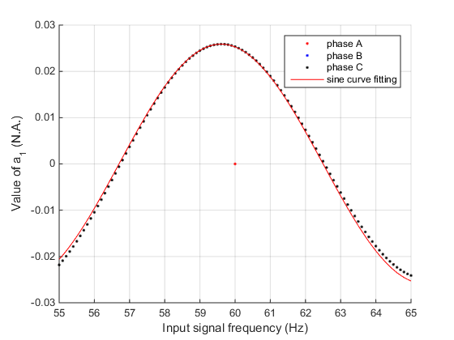

Figure 1‑15 Fitting of value using cosine curve

Notice that of phase A could be ignored when since . Besides this point, the others can be fitted using a sinusoidal curve:

The fitting is accurate in the middle part and the error increases when the frequency departs from the nominal frequency. It should be noted that the maximum value of the fitted curve reached at the frequency of 56.7 Hz rather than 60 Hz, the nominal frequency.

is nearly 0 for all 3 phases. This is because the angle shift of the filter in this frequency band is nearly 0, and the angle error contributed by the estimation algorithm is also near 0.

The value of initial phase angle is shown in Figure 1‑6. It is the same as voltage case show in Figure 1‑16.

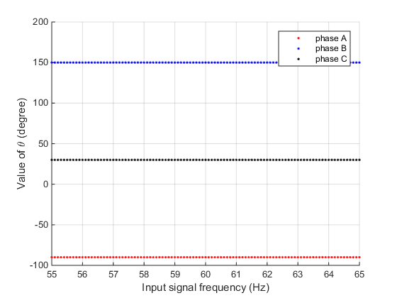

Figure 1‑16 The value vs. different input frequencies

It can be seen that the phase angle , where is the initial phase angle of each phase.

In this way, the phase error of voltage and current measurement in the frequency range test can be decided.

Similar to the in magnitude error, after deep investigation, it is found that

It is shown in Figure 1‑17.

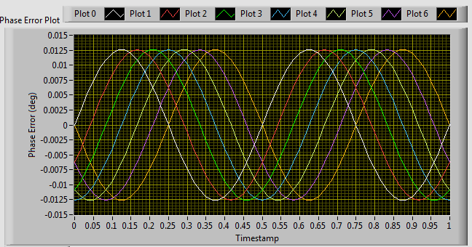

Figure 1‑17 Magnitude error behavior of frequency range test when is changing from (Plot 0) (Plot 1), to (Plot 6).

### Frequency Error

For each fixed input frequency, the frequency error is a constant value. The constant value is dependent on the input frequency, and their relationship is shown in Figure 1‑17.

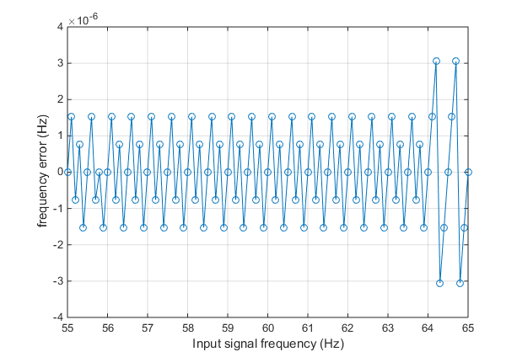

Figure 1‑17 The frequency error vs. input signal frequency

It shows that there are generally 7 values of frequency error: 0, , , and . All of them are very small.

It looks like they are from the round off error. . It looks like the least significant bit of a 17-bit number and 10 is the denominator in the weighted algorithm of frequency estimation.

It is also strange that both the measurement and true frequency in the spreadsheet are equal. It is not known yet why the frequency error is not 0. Probably the precision of the test system is higher than the result shown in data file.

Since the frequency error is smaller than 0.1% of the requirement in standard, it is reasonable to be considered as 0.

### ROCOF Error

Since the measured frequency is constant, the ROCOF error should be 0. In the spreadsheet, their absolute values are less than , and they are considered to be from the finite precision round off error. Therefore, ROCOF error is also considered as 0.

## Magnitude Range

### Magnitude Error

#### Voltage

The voltage magnitude error is a constant value for each voltage magnitude deviation. Some of the voltage magnitude error is shown in Figure 1‑16.

Figure 1‑19 Voltage magnitude error upon different voltage value

The voltage magnitude error is linearly dependent on the input voltage magnitude, as shown in Figure 1‑20.

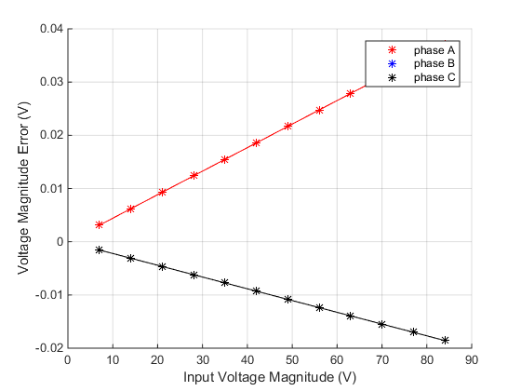

Figure 1‑20 The voltage magnitude error vs. different input voltage magnitude in percentage

It can be described by the following linear function.

The value of coefficients and are calculated using linear regression, and are shown in Table 1‑1.

Table 1‑1 Coefficients of voltage magnitude error linear regression

|  |  |  |
| --- | --- | --- |
|  |  |  |
| Phase A | 0.000442115384615390 | -6.27777315338817e-16 |
| Phase B | -0.000220981159517517 | -1.34869017584592e-06 |
| Phase C | -0.000220981159517517 | -1.34869017584592e-06 |

It can be seen that is nearly 0, and the of phase B and C equals to multiplies the of phase A.

#### Current

The current magnitude error is also a constant value for each current magnitude deviation. Some of the current magnitude error is shown in Figure 1‑18.

Figure 1‑20 Current magnitude error upon different current value

The current magnitude error is linearly dependent on the input current magnitude, as shown in Figure 1‑19.

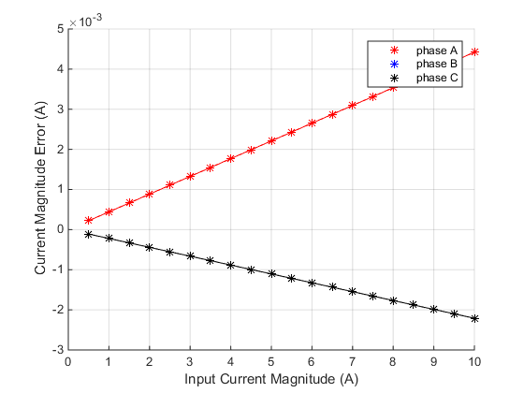

Figure 1‑21 The current magnitude error vs. different input current magnitude in percentage

It can be described by the following linear function.

The value of coefficients and are calculated using linear regression, and are shown in Table 1‑2.

Table 1‑2 Coefficients of current magnitude error linear regression

|  |  |  |
| --- | --- | --- |
|  |  |  |
| Phase A | 0.000442109924812002 | -2.21052630547536e-08 |
| Phase B | -0.000221021181155353 | 1.11667526864825e-07 |
| Phase C | -0.000221021181155353 | 1.11667526864825e-07 |

Similar to the voltage, is nearly 0, and the of phase B and C equals to multiplies the of phase A.

Comparing the coefficients and of voltage and current, it can be found that the coefficients of voltage and current are identical. Therefore, the magnitude error of both voltage and current can be represented in a uniform equation.

is the effective value of input magnitude, is the initial phase angle of the input signal, and coefficients and can be found from Table 1‑1.

### Phase Error

Similar to the phase error in frequency range test, there is time round off error in magnitude range test. The phenomenon is the given true value of the imaginary part shows a triangle wave, shown in Figure 1‑20.

Figure 1‑22 The given true value of the imaginary part of voltage in phase A

Since we know the true value of phase angles are and for phase A, B, and C, respectively, we simply use the measured angle minus true values as the error.

It is found that all the phase errors are fixed values for each test. For phase A, the absolute value of phase angle error is less than , therefore it can be considered as 0. For phase B, the angle error is from -0.021955 to -0.021935, with not specific principle, shown in Figure 1‑21. The phase angle error in phase C is the opposite value of the corresponding error in phase B. The phase angle error of current is very close to voltage in corresponding phases, and the example of phase B is shown in Figure 1‑22.

Figure 1‑23 Phase angle error of voltage in phase B

Figure 1‑24 Phase angle error of current in phase B

To simplify the formulation, the phase error can be described as

Be aware that these values can be calculated using the formulas in Section 1.1.2 by setting .

### Frequency Error

The frequency error is 0 for all the cases.

### ROCOF Error

The ROCOF errors are within , so they are considered to be 0.

## Harmonics

### Magnitude Error

The voltage magnitude error is a constant value for each harmonic component, shown in Figure 1‑23.

Figure 1‑25 Voltage magnitude error upon different voltage value

The voltage magnitude errors didn’t show obvious relation with the harmonic order. The magnitude errors of phase A are listed in Table 1‑3.

Table 1‑3 Magnitude error of phase A upon different orders of harmonic distortion

|  |  |  |  |  |  |  |  |
| --- | --- | --- | --- | --- | --- | --- | --- |
| Harmonic order | 2 | 3 | 4 | 5 | 6 | 7 | 8 |
| Magnitude Error (V) | 0.03537 | 0.03296 | 0.03022 | 0.02934 | 0.03019 | 0.0316 | 0.03226 |

Compare voltage magnitude error and current magnitude error, it is found that the error ratio between each pair with the same harmonic order equals to the ratio between voltage magnitude and current magnitude, i.e.

Compare magnitude error between different phases, it is found that the error of phase B and phase C equals to -0.5 multiplies the corresponding magnitude error in phase A.

Therefore, the magnitude error caused by harmonics can be written as

In this equation, is the magnitude of the objective signal (voltage or current, effective value); is the reference voltage magnitude, i.e. here; is the coefficient shown in Table 1‑3 with as the harmonic order; is the initial value of the input signal, and here it is , and for phase A, B, and C, respectively.

For positive sequence voltage, the magnitude errors is smaller, and listed in Table 1‑4.

Table 1‑4 Magnitude error of positive sequence upon different orders of harmonic distortion

|  |  |  |  |  |  |  |  |
| --- | --- | --- | --- | --- | --- | --- | --- |
| Harmonic order | 2 | 3 | 4 | 5 | 6 | 7 | 8 |
| Magnitude Error (V) | 0.00068 | 0 | 0.00068 | -0.00053 | 0 | -0.00053 | 0.00066 |

It can be seen that 3rd the 6th harmonics have no influence on the positive sequence measurement.

The other harmonics are symmetric respect to these zero sequence components. That is and

### Phase Error

Similar to phase error in frequency range and magnitude range, the phase error here is also computed according to the theoretical true value and the measurement results. It is found that in each test, the phase errors of voltage and current are the same in the same phase.

In phase A, the phase error is between and , so it can be considered as 0. The error in phase B is shown in Figure 1‑24. The error in phase C is the opposite value of phase B.

Figure 1‑26 Phase angle error of phase B upon different orders of harmonic distortion

The relation between phase angle error and harmonic order is not obvious, but it is reasonable to describe the phase angle error using the following formula.

Here is listed in Table 1‑4.

Table 1‑4 Coefficient of phase angle error during harmonics distortion

|  |  |  |  |  |  |  |  |
| --- | --- | --- | --- | --- | --- | --- | --- |
| Harmonic order (i) | 2 | 3 | 4 | 5 | 6 | 7 | 8 |
|  | 0.028394 | 0.023691 | 0.024181 | 0.024455 | 0.025959 | 0.026307 | 0.025877 |

### Frequency Error

The frequency error is fixed for each test, and listed in Table 1‑5.

Table 1‑5 Coefficient of phase angle error during harmonics distortion

|  |  |  |  |  |  |  |  |
| --- | --- | --- | --- | --- | --- | --- | --- |
| Harmonic order (i) | 2 | 3 | 4 | 5 | 6 | 7 | 8 |
|  | -0.00137 | 0 | 0.00137 | 0.00082 | 0 | -0.00082 | 0.00055 |

According to the test, the harmonics and the fundamental signal are in-phase by crossing zero in the positive-going direction at the same time. That means that the 2nd, 5th, 8th harmonic are negative sequence, the 3rd, 6th are zero sequence, and the 4th and 7th are positive sequence.

It can be seen that 3rd the 6th harmonics have no influence on the frequency measurement.

The other harmonics are symmetric respect to these zero sequence components with a minus. That is and

### ROCOF Error

The ROCOF errors are within , so they are considered to be 0.

## Interharmonics

In the interharmonic test, the frequency band is defined as . For 60 Hz nominal frequency and 60 Hz reporting rate, it is . The test range is . 3 fundamental frequencies are tested: and . Magnitude of the interharmonic component is 10%. It should be notice that the case of 120 Hz is actually the second harmonics, and it behaviors different from the interharmonics; therefore, it will not be discussed here when input frequency equals to the nominal frequency, since it was already discussed in Sec 1.3. 120 Hz input is discussed only when the input frequency has a deviation from the nominal frequency.

### Magnitude Error

First work with the situations when .

When the frequency of interharmonic is less than the lower boundary of the band, the voltage magnitudes of the phase A are drawn in Figure 1‑25.

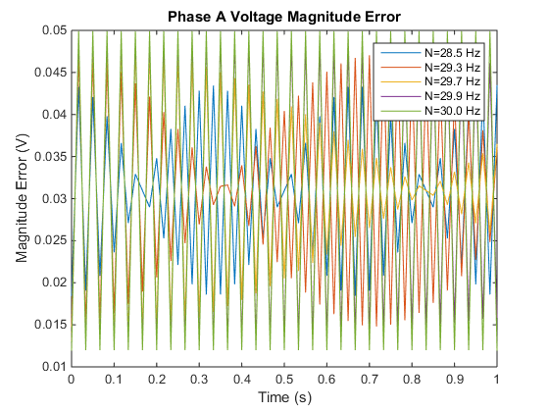

Figure 1‑27 Voltage magnitude error of phase A upon different interharmonic distortion ()

It can be observed that the voltage magnitude errors behaviors as the sinusoidal waveform with the frequency equals to the interharmonic frequency. At a first glance of the figure, it looks like there are some amplitude modulation of the magnitude error. However, it is actually because the Nyquist frequency is close to the magnitude error frequency, and the sampling frequency is not an integer times of the magnitude error frequency.

When the frequency of interharmonic is larger than the higher boundary of the band, the voltage magnitudes of the phase A are drawn in Figure 1‑26.

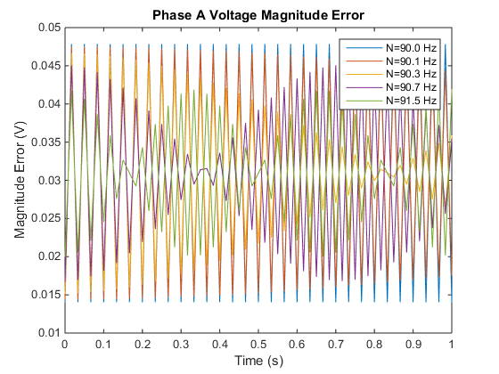

Figure 1‑28 Voltage magnitude error of phase A upon different interharmonic distortion ()

It can be seen that the magnitude errors from interharmonic on both sides are symmetric. This is because the reporting rate is 60 Hz, and the frequency components are symmetric to it. In this case, the magnitude error of higher bound can also be described by a sinusoidal waveform with the frequency equal to the interharmonic frequency. The ‘modulation’ in the figure is because the Nyquist frequency is lower than the magnitude error frequency.

The voltage magnitude error can then be described as

Where

The amplitude coefficient is plotted in Figure 1‑30.

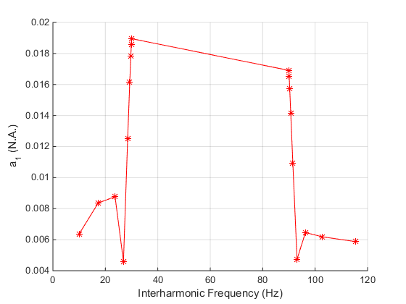

Figure 1‑30 Coefficient upon different interharmonic frequency

It behaviors like a band pass filter centralized in . The can be regressed by serval segments of lines.

Table 1‑7 and of Coefficient in Phase A

|  |  |  |
| --- | --- | --- |
|  |  |  |
| 10 - 23.7 | 1.774e-4 | 4.820e-3 |
| 23.7 – 26.9 | -1.305e-3 | 3.969e-2 |
| 26.9 - 30 | 4.645e-3 | -1.202e-1 |
| 90 – 93.1 | -3.9378e-3 | 3.713e-1 |
| 93.1 – 96.3 | 5.373e-4 | -4.529e-2 |
| 96.3 – 115.5 | -2.952e-5 | 9.266e-3 |

The offset is ranged from 0.30945 to 0.3095. Use the constant value 0.309475 to represent it.

Initial angle except for and where .

Phase B and C can also be described using

Where

The coefficient of phase B and phase C are identical. It is regressed by the same method of in phase A.

Table 1‑8 and of Coefficient in phase B and phase C

|  |  |  |
| --- | --- | --- |
|  |  |  |
| 10 - 23.7 | -2.745e-04 | 1.056e-02 |
| 23.7 – 29.9 | 1.383e-03 | -2.871e-02 |
| 29.9 - 30 | -9.673e-02 | 2.905e+00 |
| 90 – 90.1 | 5.453e-02 | -4.900e+00 |
| 90.1 – 96.3 | -1.516e-03 | 1.499e-01 |
| 96.3 – 115.5 | 1.339e-04 | -8.351e-03 |

The results are shown in Figure 1‑31.

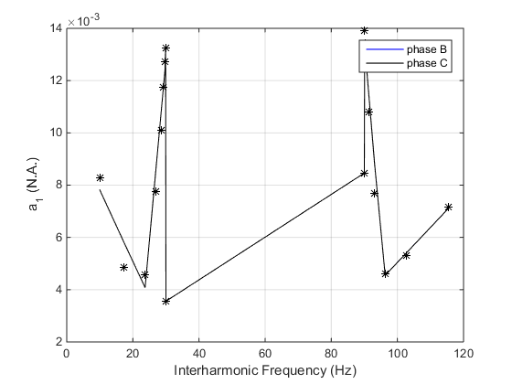

Figure 1‑31 Coefficient of phase B and C upon different interharmonic frequency

The coefficient of phase B and C equals to -0.5 times of phase A. Therefore, for the 3 phases can be written as

Where is the initial phase angle of the input signal (, and for phase A, B, and C, respectively).

Initial angle shows no obvious principle. For phase B, it is plotted in Figure 1‑32.

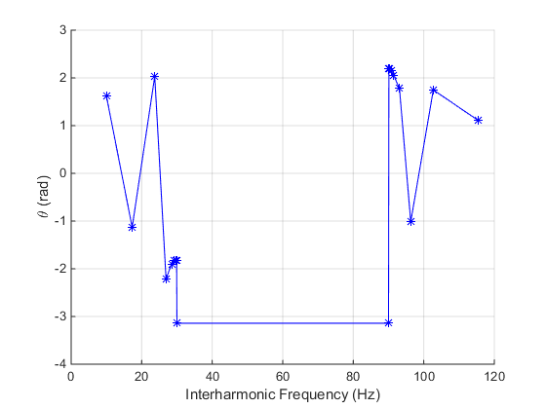

Figure 1‑32 Coefficient of phase B upon different interharmonic frequency

The of phase C is the opposite value of phase B.

It can be observed that when and , . For other cases, is regressed by several line segments.

Table 1‑9 and of Coefficient in phase B and phase C

|  |  |  |
| --- | --- | --- |
|  |  |  |
| 10 – 17.3 | -0.37642 | 5.38157 |
| 17.3 – 23.7 | 0.493953 | -9.67594 |
| 23.7 – 26.9 | -1.32504 | 33.43431 |
| 26.9 – 29.9 | 0.12759 | -5.60464 |
| 30, 90 | 0 |  |
| 90.1 – 93.1 | -0.14373 | 15.17251 |
| 93.1 – 96.3 | -0.87181 | 82.94253 |
| 96.3 – 102.7 | 0.431519 | -42.5685 |
| 102.7 – 115.5 | -0.05031 | 6.915536 |

Current magnitude error behaviors similar to the corresponding voltage magnitude error in each phase, except the parameters are different. The ratio between two groups of parameters equals to the ratio between the true magnitude inputs. This indicates that the parameters and is also proportional to the input magnitude.

The magnitude error of voltage and current in 3 phases can be described using algebra equations below.

Here is the frequency of interharmonic, and and can be looked up in Table 1‑10.

Table 1‑10 and of Coefficient

|  |  |  |  |  |  |
| --- | --- | --- | --- | --- | --- |
| Phase A | | | Phase B and C | | |
|  |  |  |  |  |  |
| 10 - 23.7 | 1.774e-4 | 4.820e-3 | 10 - 23.7 | -2.745e-04 | 1.056e-02 |
| 23.7 – 26.9 | -1.305e-3 | 3.969e-2 | 23.7 – 29.9 | 1.383e-03 | -2.871e-02 |
| 26.9 - 30 | 4.645e-3 | -1.202e-1 | 29.9 - 30 | -9.673e-02 | 2.905e+00 |
| 90 – 93.1 | -3.9378e-3 | 3.713e-1 | 90 – 90.1 | 5.453e-02 | -4.900e+00 |
| 93.1 – 96.3 | 5.373e-4 | -4.529e-2 | 90.1 – 96.3 | -1.516e-03 | 1.499e-01 |
| 96.3 – 115.5 | -2.952e-5 | 9.266e-3 | 96.3 – 115.5 | 1.339e-04 | -8.351e-03 |

when and , otherwise. (phase A)

Table 1‑11 and of Coefficient in phase B and phase C

|  |  |  |
| --- | --- | --- |
|  |  |  |
| 10 – 17.3 | -0.37642 | 5.38157 |
| 17.3 – 23.7 | 0.493953 | -9.67594 |
| 23.7 – 26.9 | -1.32504 | 33.43431 |
| 26.9 – 29.9 | 0.12759 | -5.60464 |
| 30, 90 | 0 |  |
| 90.1 – 93.1 | -0.14373 | 15.17251 |
| 93.1 – 96.3 | -0.87181 | 82.94253 |
| 96.3 – 102.7 | 0.431519 | -42.5685 |
| 102.7 – 115.5 | -0.05031 | 6.915536 |

When the fundamental frequency is unequal to the nominal frequency, the measurement error is more complicated. The voltage magnitude error of phase A when is shown in Figure 1‑30.

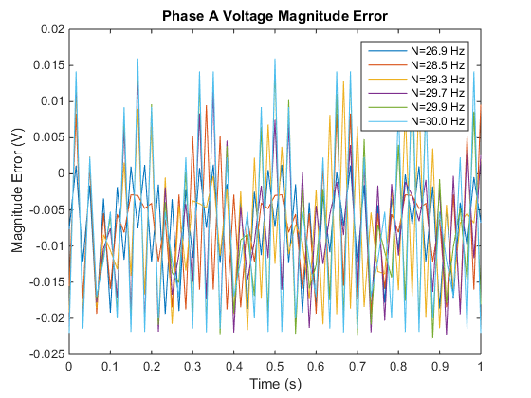

Figure 1‑31 Voltage magnitude error of phase A upon different interharmonic distortion ()

From the spectrum analysis, it is observed that there are 3 main frequency components in the magnitude error.

1. 6 Hz, which is from 57 Hz fundamental frequency. It was analyzed in section 1.1.1.
2. The frequency folded from () into the range.
3. The frequency folded from () into the range.

The voltage and current magnitude error can then be described as

Where

Now we analyze the magnitude error from each frequency component.

1. 6 Hz from 57 Hz fundamental frequency.

In voltage data, , , and for all three phases. and can be calculated using the formula in frequency range (Section 1.1.1).

1. component. For 30 Hz and 90 Hz, the two components and are folded into the same frequency after sampling, therefore their are larger than others. for the other components are plotted and regressed in Figure 1‑30 and Table 1‑11.

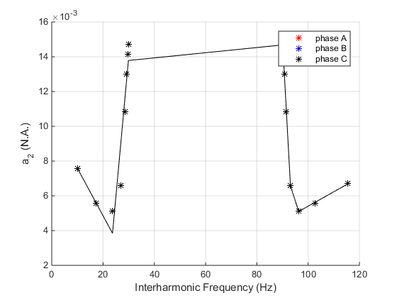

Figure 1‑32 Coefficient upon different interharmonic frequency

Table 1‑12 and of Coefficient

|  |  |  |
| --- | --- | --- |
|  |  |  |
| 10 – 17.3 | -2.737E-04 | 1.033E-02 |
| 17.3 – 23.7 | -7.307E-05 | 6.855E-03 |
| 23.7 – 29.9 | 1.603E-03 | -3.414E-02 |
| 30 | 0 | 1.896E-02 (phase A)  1.3072E-02 (phase B and phase C) |
| 90 | 0 | 1.691E-02 |
| 90.1 – 93.1 | -2.710E-03 | 2.588E-01 |
| 93.1 – 96.3 | -4.562E-04 | 4.905E-02 |
| 96.3 – 115.5 | 8.286E-05 | -2.882E-03 |

for phase A equals to 0 when and , and otherwise.

. Use linear regression for phase B.

Table 1‑13 and of Coefficient

|  |  |  |
| --- | --- | --- |
|  |  |  |
| 10 – 17.3 | 0.467103 | -6.39806 |
| 17.3 – 23.7 | -0.45411 | 9.539009 |
| 23.7 – 26.9 | 1.018489 | -25.3617 |
| 26.9-30 | 0.03672 | 1.047909 |
| 90-93.1 | 0.036748 | -5.23633 |
| 93.1 – 96.3 | 1.018474 | -96.635 |
| 96.3 – 102.7 | -0.45411 | 45.17505 |
| 102.7-120 | 0.03674 | -5.23556 |

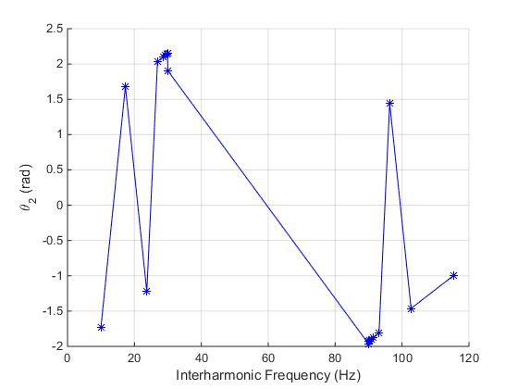

Figure 1‑33 Coefficient upon different interharmonic frequency

1. component. This component has nothing for and since they are counted as for both interharmonic frequencies. Again, is given by linear regression in segments in Figure 1‑33 and Table 1‑15.

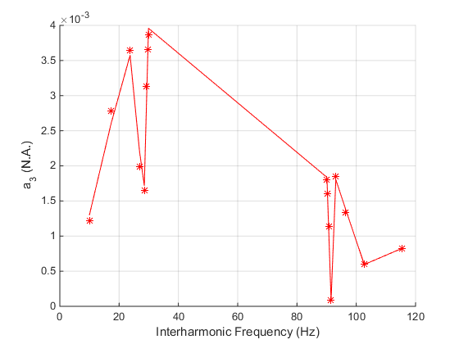

Figure 1‑34 Coefficient upon different interharmonic frequency

Table 1‑13 and of Coefficient

|  |  |  |
| --- | --- | --- |
|  |  |  |
| 10 – 23.7 | 1.779E-04 | -4.745E-04 |
| 23.7 – 28.5 | -4.296E-04 | 1.376E-02 |
| 28.5 – 29.9 | 1.601E-03 | -4.391E-02 |
| 30 | 0 | 0 |
| 90 | 0 | 0 |
| 90.1 – 91.5 | -1.239E-03 | 1.135E-01 |
| 91.5 – 93.1 | 1.102E-03 | -1.008E-01 |
| 93.1 – 102.7 | -1.281E-04 | 1.373E-02 |
| 102.7 – 115.5 | 1.804E-05 | -1.257E-03 |

for phase A equals to 0 when and otherwise.

. Use linear regression to fit .

Table 1‑12 and of Coefficient

|  |  |  |
| --- | --- | --- |
|  |  |  |
| 10 – 17.3 | -0.03678 | 1.04778 |
| 17.3 – 23.7 | -0.52761 | 9.539159 |
| 23.7 – 26.9 | -0.03674 | -2.09458 |
| 26.9-30 | 0.997777 | -29.4373 |
| 90-93.1 | 0.997619 | -92.597 |
| 93.1 – 96.3 | -0.0367 | 4.184817 |
| 96.3 – 102.7 | -0.52757 | 51.45563 |
| 102.7-120 | 0.208621 | -24.1513 |

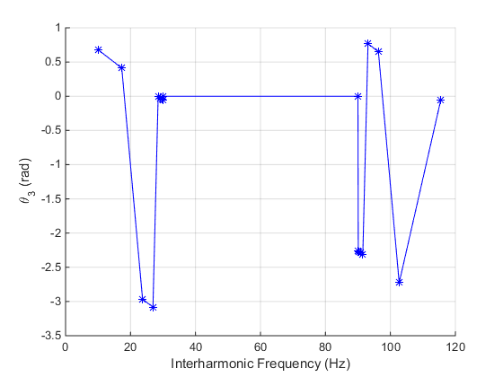

Figure 1‑35 Coefficient upon different interharmonic frequency

Similar to the situation of when he voltage magnitude error can also be described as

Where

Using the same method to get the algebra equation for all the parameters.

Other parameters are nearly the same as those when

### Phase Error

First work with the situations when .

The phase error is similar to the magnitude error, as it behaviors like a sinusoidal waveform with the frequency equals to the interharmonic frequency. The phase angle error of voltage and current are identical, and can be described as

Where

The amplitude coefficient is plotted in Figure 1‑35, except the point of when and when .

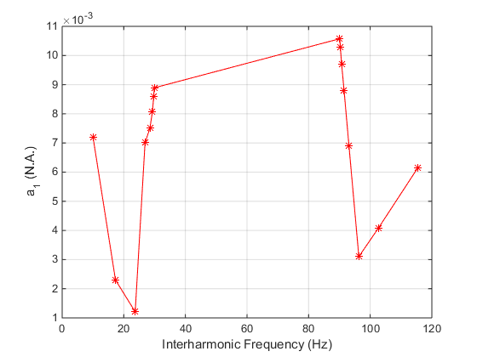

Figure 1‑36 Coefficient of phase A upon different interharmonic frequency

The can be regressed by serval segments of lines.

Table 1‑14 and of Coefficient

|  |  |  |  |  |  |
| --- | --- | --- | --- | --- | --- |
| Phase A | | | Phase B and C | | |
|  |  |  |  |  |  |
| 10 – 17.3 | -0.00067 | 0.013931 | 10 – 23.7 | 3.41E-05 | 0.005443 |
| 17.3 – 23.7 | -0.00017 | 0.005254 | 23.7 – 26.9 | -0.00046 | 0.017037 |
| 23.7 – 26.9 | 0.001814 | -0.04177 | 26.9 - 30 | 0.002566 | -0.0638 |
| 26.9 – 29.9 | 0.000599 | -0.00926 | 90 – 93.1 | -0.00254 | 0.241046 |
| 30 | 0 | 0 | 93.1 – 115.5 | 1.66E-05 | 0.003228 |
| 90 | 0 | 0.8857 |  |  |  |
| 90.1 – 96.3 | -0.0012 | 0.118288 |  |  |  |
| 96.3 – 115.5 | 0.000159 | -0.01227 |  |  |  |

The offset is also fixed value for each phase.

For phase A, initial angle except for and where .

of phase B and C lacks obvious principle, shown in Figure 1‑36. Similar to the of magnitude error, here we also use several lines to do the regression.

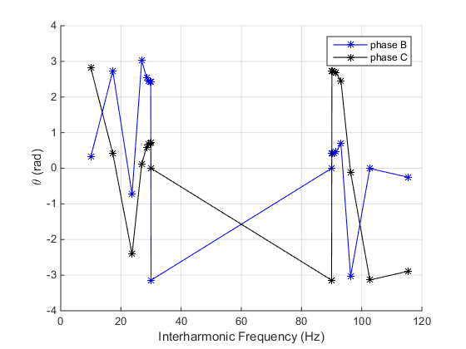

Figure 1‑37 Coefficient of phase B and C upon different interharmonic frequency

and are symmetric regard , i.e.

Table 1‑15 and of Coefficient in phase B and phase C

|  |  |  |
| --- | --- | --- |
|  |  |  |
| 10 – 17.3 | 0.32930 | -2.96747 |
| 17.3 – 23.7 | -0.54059 | 12.08162 |
| 23.7 – 26.9 | 1.17368 | -28.54640 |
| 26.9 – 29.9 | -0.20185 | 8.40331 |
| 30 | 0 |  |
| 90 | 0 | 0 |
| 90.1 – 93.1 | 0.09116 | -7.82278 |
| 93.1 – 96.3 | -1.16423 | 109.08085 |
| 96.3 – 102.7 | 0.47308 | -48.59210 |
| 102.7 – 115.5 | -0.01923 | 1.96807 |

The phase error of voltage and current in 3 phases can be described using algebra equations below.

and can be found in Table 1‑11.

when and , otherwise. (phase A)

and can be found in Table 1‑12.

When the fundamental frequency is unequal to the nominal frequency, the measurement error is more complicated. Notify the phase errors of both voltage and current are the same in corresponding phases. The voltage phase error of phase A when is shown in Figure 1‑37.

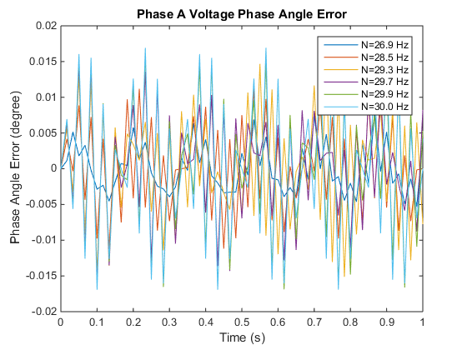

Figure 1‑38 Voltage phase error of phase A upon different interharmonic distortion ()

From the spectrum analysis, it is observed that there are 3 main frequency components in the magnitude error.

According to the frequency spectrum analysis, the phase angle error, similar to the magnitude error when , can also be described as

Where

Analyze these 3 frequency components in the same way as we did in Sec. 1.4.1.2.

1. 6 Hz from 57 Hz fundamental frequency.

. , and for all three phases. Notice that this follows the same rule given in Sec. 1.1.2.

1. component. For 30 Hz and 90 Hz, the two components and are folded into the same frequency after sampling, therefore their are larger than others. for the other components are regressed in Table 1‑16.

Table 1‑16 and of Coefficient

|  |  |  |
| --- | --- | --- |
|  |  |  |
| 10 – 17.3 | -2.241E-04 | 8.453E-03 |
| 17.3 – 23.7 | -5.977E-05 | 5.611E-03 |
| 23.7 – 29.9 | 1.312E-03 | -2.795E-02 |
| 30 | 0 | 1.552E-02 (phase A)  1.070E-02 (phase B and phase C) |
| 90 | 0 | 1.385E-02 |
| 90.1 – 93.1 | -2.218E-03 | 2.119E-01 |
| 93.1 – 96.3 | -3.732E-04 | 4.013E-02 |
| 96.3 – 115.5 | 6.769E-05 | -2.344E-03 |

for phase A equals to when and , and otherwise. and it is shown in Figure 1‑41 (b). According to the comparison with the of magnitude error, it can be concluded that

|  |  |
| --- | --- |
|  |  |
| (a) | (b) |

Figure 1‑41 Coefficient upon different interharmonic frequency (a) magnitude error (b) phase error

1. component. This component has nothing for and since they are counted as for both interharmonic frequencies. Again, is given by linear regression in segments in Figure 1‑39and Table 1‑17.

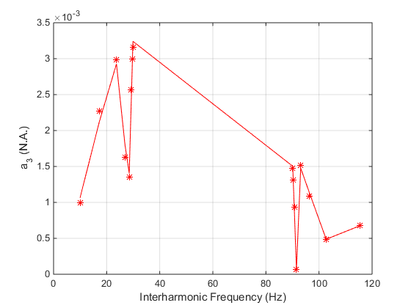

Figure 1‑40 Coefficient upon different interharmonic frequency

Table 1‑17 and of Coefficient

|  |  |  |
| --- | --- | --- |
|  |  |  |
| 10 – 23.7 | 1.456E-04 | -3.886E-04 |
| 23.7 – 28.5 | -3.519E-04 | 1.127E-02 |
| 28.5 – 29.9 | 1.312E-03 | -3.598E-02 |
| 30 | 0 | 0 |
| 90 | 0 | 0 |
| 90.1 – 91.5 | -1.015E-03 | 9.300E-02 |
| 91.5 – 93.1 | 9.035E-04 | -8.260E-02 |
| 93.1 – 102.7 | -1.049E-04 | 1.124E-02 |
| 102.7 – 115.5 | 1.477E-05 | -1.030E-03 |

Similar to .

The method and algebra equation is the same as .

Where

In voltage data,

Other parameters are very close to those when .

### Frequency Error

First work with the situations when .

Similar to the magnitude and phase error, the frequency can be described a sinusoidal waveform with the frequency equals to the interharmonic frequency.

Where

The value of regarding to interharmonic frequency is shown in Figure 1‑40.

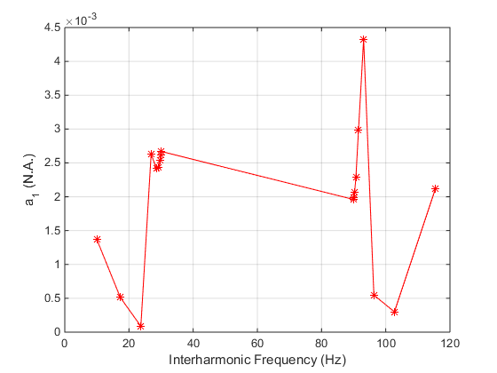

Figure 1‑41 Coefficient upon different interharmonic frequency

We still use segments of linear regression to represent the behavior of .

Table 1‑18 and of Coefficient

|  |  |  |
| --- | --- | --- |
|  |  |  |
| 10 – 23.7 | -9.40E-05 | 0.002253 |
| 23.7 – 26.9 | 0.000795 | -0.018749 |
| 26.9 – 28.5 | -0.00013 | 0.006133 |
| 28.5 – 30 | 0.00016 | -0.002172 |
| 90 – 93.1 | 0.000778 | -0.068144 |
| 93.1 – 96.3 | -0.00118 | 0.114347 |
| 96.3 – 102.7 | -3.86E-05 | 0.004268 |
| 102.7 – 115.5 | 0.000142 | -0.014317 |

If when and and otherwise.

If , .

Since the frequency is the differentiation of the phase, it is easy to understand that the frequency error will also include the 3 frequency components.

Where

Table 1‑19 and of Coefficient

|  |  |  |
| --- | --- | --- |
|  |  |  |
| 10 – 17.3 | 1.756E-05 | 9.758E-04 |
| 17.3 – 23.7 | 1.178E-05 | 1.076E-03 |
| 23.7 – 29.9 | 4.331E-04 | -9.244E-03 |
| 30 | 0 | 2.483E-03 |
| 90 | 0 | 1.409E-03 |
| 90.1 – 93.1 | -7.448E-04 | 7.099E-02 |
| 93.1 – 96.3 | -1.488E-04 | 1.552E-02 |
| 96.3 – 115.5 | -5.399E-05 | 6.425E-03 |

when

when .

Table 1‑20 and of Coefficient

|  |  |  |
| --- | --- | --- |
|  |  |  |
| 10 – 23.7 | 7.927E-05 | -5.837E-04 |
| 23.7 – 28.5 | -1.414E-04 | 4.624E-03 |
| 28.5 – 29.9 | 6.316E-04 | -1.734E-02 |
| 30 | 0 | 0 |
| 90 | 0 | 0 |
| 90.1 – 91.5 | -1.684E-03 | 1.542E-01 |
| 91.5 – 93.1 | 1.630E-03 | -1.490E-01 |
| 93.1 – 102.7 | -1.723E-04 | 1.874E-02 |
| 102.7 – 115.5 | 4.444E-05 | -3.504E-03 |

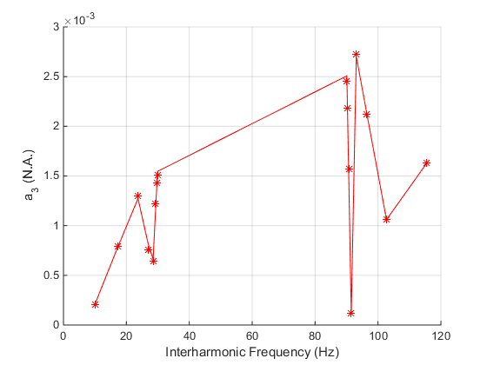

Figure 1‑42 Coefficient upon different interharmonic frequency

when

when .

The method and algebra equation is the same as .

Where

All the parameters are nearly the same as those when .

### ROCOF Error

First work with the situations when .

Similar to the magnitude and phase error, the frequency can be described a sinusoidal waveform with the frequency equals to the interharmonic frequency.

Where

The value of regarding to interharmonic frequency is shown in Figure 1‑40.

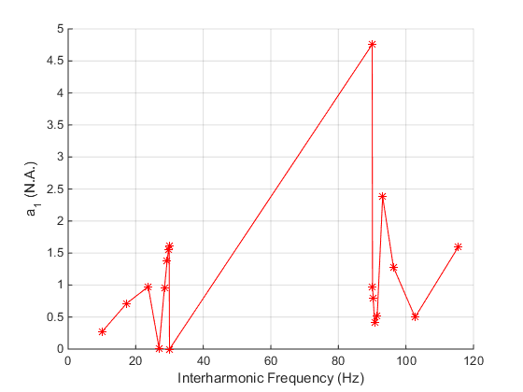

Figure 1‑43 Coefficient upon different interharmonic frequency

We still use segments of linear regression to represent the behavior of .

Table 1‑21 and of Coefficient

|  |  |  |
| --- | --- | --- |
|  |  |  |
| 10 – 23.7 | 0.0517 | -0.2275 |
| 23.7 – 26.9 | -0.3000 | 8.0855 |
| 26.9 – 29.9 | 0.5400 | -14.4841 |
| 30 | 0 | 0 |
| 90 | 0 | 4.76 |
| 90.1 – 90.7 | -0.9164 | 83.5386 |
| 90.7 – 91.5 | 0.1321 | -11.5679 |
| 91.5 – 93.1 | 1.1610 | -105.7068 |
| 93.1 – 102.7 | -0.1857 | 19.4629 |
| 102.7 – 115.5 | 0.0858 | -8.3161 |

If when and when , and otherwise.

If , when and , and otherwise.

Since the ROCOF is the differentiation of the frequency, it is easy to understand that the ROCOF error will also include the 3 frequency components.

Where

Table 1‑22 and of Coefficient

|  |  |  |
| --- | --- | --- |
|  |  |  |
| 10 – 17.3 | -2.654E-03 | 3.614E-01 |
| 17.3 – 23.7 | -5.352E-03 | 4.080E-01 |
| 23.7 – 29.9 | 6.551E-02 | -1.325E+00 |
| 30 | 0 | 1.195E-01 |
| 90 | 0 | 2.847E-00 |
| 90.1 – 93.1 | -1.438E-01 | 1.376E+01 |
| 93.1 – 96.3 | -2.615E-02 | 2.809E+00 |
| 96.3 – 115.5 | -1.250E-02 | 1.516E+00 |

Table 1‑23 and of Coefficient

|  |  |  |
| --- | --- | --- |
|  |  |  |
| 10 – 23.7 | 3.945E-02 | -3.155E-01 |
| 23.7 – 28.5 | -6.497E-02 | 2.156E+00 |
| 28.5 – 29.9 | 3.298E-01 | -9.062E+00 |
| 30 | 0 | 0 |
| 90 | 0 | 0 |
| 90.1 – 91.5 | -1.328E+00 | 1.217E+02 |
| 91.5 – 93.1 | 1.303E+00 | -1.192E+02 |
| 93.1 – 102.7 | -1.343E-01 | 1.467E+01 |
| 102.7 – 115.5 | 4.158E-02 | -3.390E+00 |

The method and algebra equation is the same as .

Where

All the parameters are nearly the same as those when .

# Frequency Ramp

## Magnitude Error

The magnitude error during frequency ramp is a bit more complex than steady state, shown in Figure 2‑1.

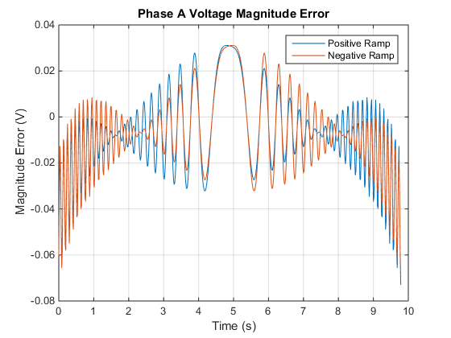

Figure 2‑1 Voltage magnitude error during frequency ramp

However, based on the frequency range result, we can decompose the magnitude error into two part.

Part 1 corresponds to the in frequency range test. It is an offset component, and is generated from the frequency-magnitude response of the filter.

Part 2 corresponds to the sinusoidal part in frequency range test. The difference is that the frequency of this sinusoidal part changes over time, since the input frequency increases or decreases linearly.

The magnitude error can be described as

Here is the initial frequency of the sinusoidal waveform, giving by the initial frequency of the frequency ramp and the equation below (same as the one in Section 1.1.1)

E.g., when testing the positive ramp, the initial input frequency is 55 Hz, the nominal frequency is 60 Hz, and .

is the frequency ramping rate, and is the initial phase angle of the corresponding phase.

For the positive sequence magnitude, it is not influenced by the frequency ramp. It is only influenced by the filter, and the magnitude error is equal to the magnitude response of the filter.

## Phase Error

The phase angle error behaviors similarly to the magnitude error except that there is no offset part.

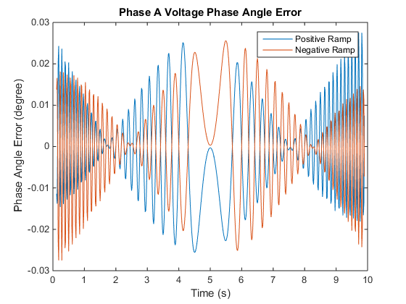

Figure 2‑2 Voltage phase angle error during frequency ramp

Similar, to the magnitude error, the phase error can be described using the following formulas.

Notice, there is still some error in this fitting which I haven’t figured out.

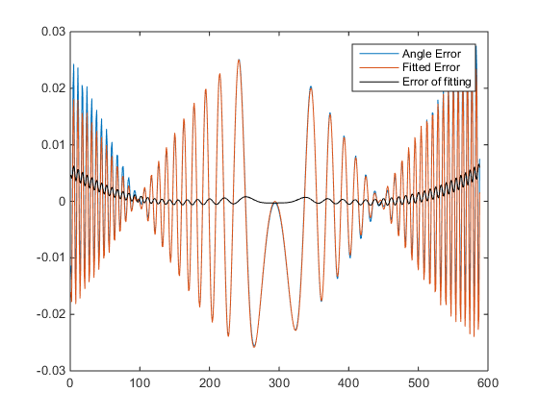

## Frequency Error

The frequency error is shown in Figure 2‑3.

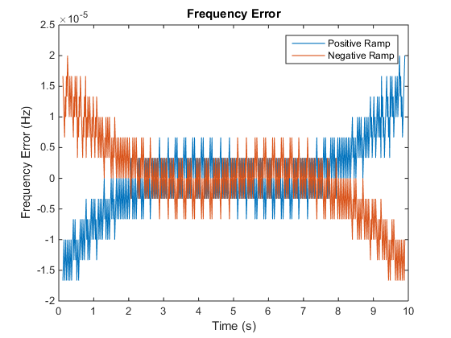

Figure 2‑3 Frequency error during frequency ramp

It can be seen that the frequency error is less than and can be ignored.

## ROCOF Error

The ROCOF error is shown in Figure 2‑4.

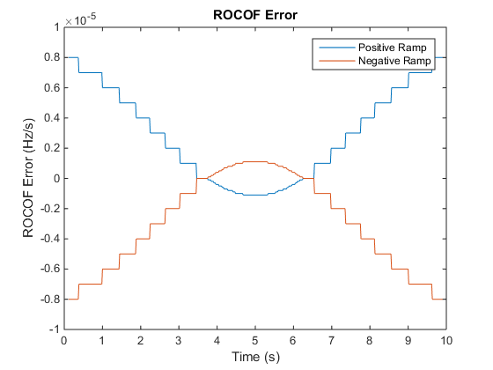

Figure 2‑4 ROCOF error during frequency ramp

It can be seen that the ROCOF error is within . It can be considered as 0.

# Modulation

## Phase Modulation

### Magnitude Error

Magnitude error of phase modulation is shown in Figure 3‑1.

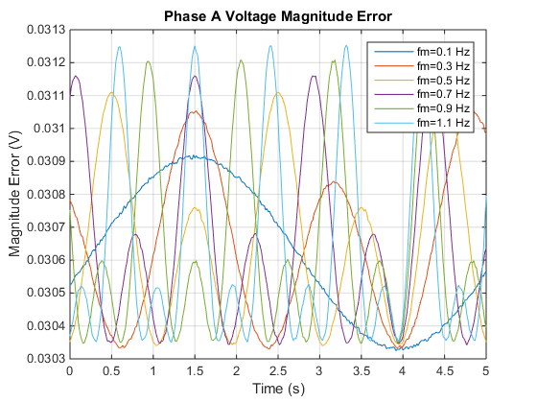

Figure 3‑1 Magnitude error during phase modulation

It can be seen from the figure plots that the magnitude error during the phase modulation is a periodical signal with a frequency equal to the modulation frequency. Spectrum analysis shows that the 2nd order harmonic also exits. Therefore, the magnitude error can be described as

Now we analyze each coefficient.

The offset varies with the modulation frequency, shown in Figure 3‑2 and Figure 3‑3.

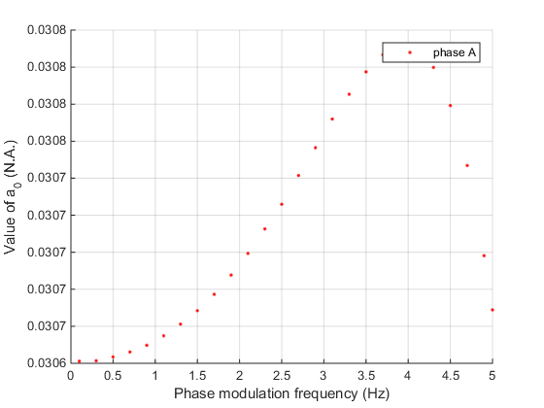

Figure 3‑2 Coefficient of phase A upon different modulation frequency

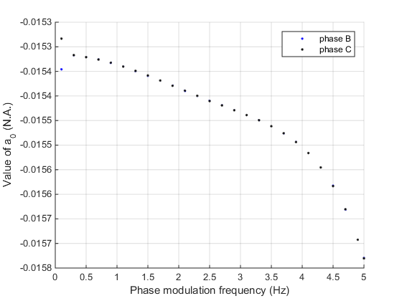

Figure 3‑3 Coefficient of phase B and C upon different modulation frequency

For phase A, it can be fitted by polynomial function as follows, and shown in Figure 3‑4.

|  |  |  |  |  |  |
| --- | --- | --- | --- | --- | --- |
|  |  |  |  |  |  |
| 0.03064 | -1.9554e-06 | 1.4471e-05 | -3.4445e-06 | 2.5790e-06 | -4.8199e-07 |

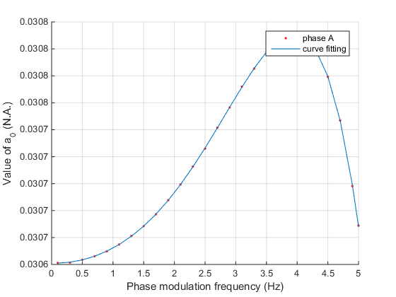

Figure 3‑4 Coefficient of phase A and curve fitting upon different modulation frequency

For phase B and C, it can be fitted by polynomial function as follows, and shown in Figure 3‑5.

|  |  |  |  |  |
| --- | --- | --- | --- | --- |
|  |  |  |  |  |
| -0.015333 | 6.5888e-05 | -9.5856e-05 | 3.2272e-06 | -3.7774e-06 |

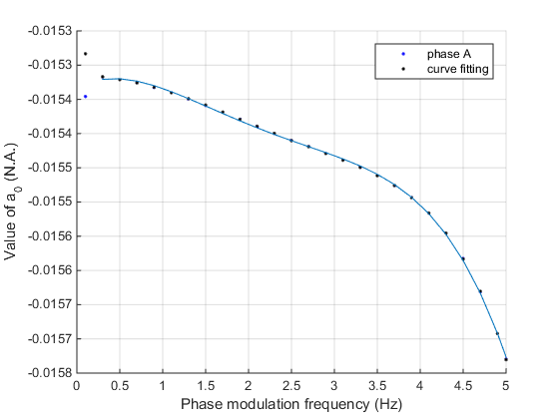

Figure 3‑5 Coefficient of phase B and C, and curve fitting upon different modulation frequency

The magnitude can be fitted by using a sinusoidal waveform, shown in Figure 3‑6 and Figure 3‑7.

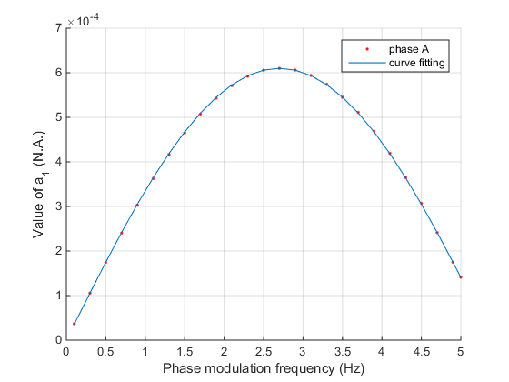

Figure 3‑6 Coefficient of phase A, and curve fitting upon different modulation frequency

For phase A, .

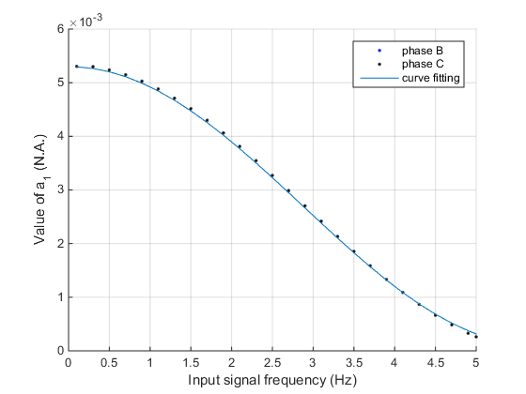

Figure 3‑7 Coefficient of phase B and C, and curve fitting upon different modulation frequency

For phase B and C, .

The initial phase angle of component is shown in Figure 3‑8 and can be fitted by linear equations.

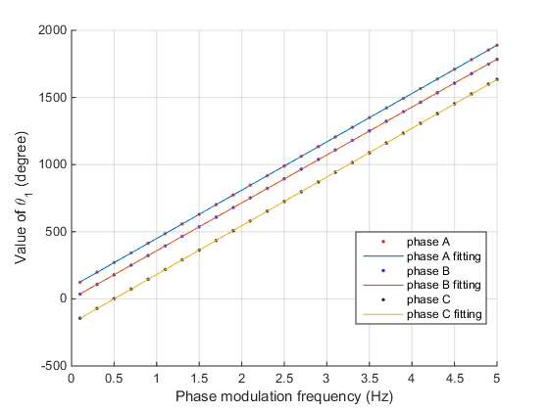

Figure 3‑8 and curve fitting upon different modulation frequency

The magnitude of the component, can be fitted by polynomial function. The fitting of all the 3 phases are the same here, shown below and in Figure 3‑9.

|  |  |  |  |  |  |
| --- | --- | --- | --- | --- | --- |
|  |  |  |  |  |  |
| 3.1046e-04 | -7.4844e-05 | 1.5616e-04 | -1.9159e-04 | 5.3465e-05 | -9.4319e-07 |

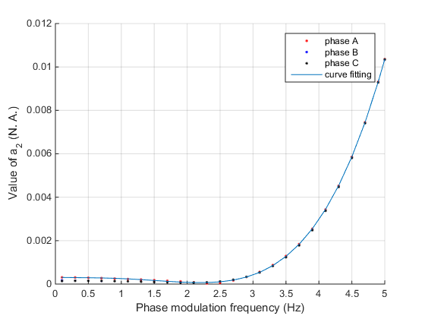

Figure 3‑9 and curve fitting upon different modulation frequency

The initial phase angle of component is shown in Figure 3‑10 and can be fitted by linear equations.

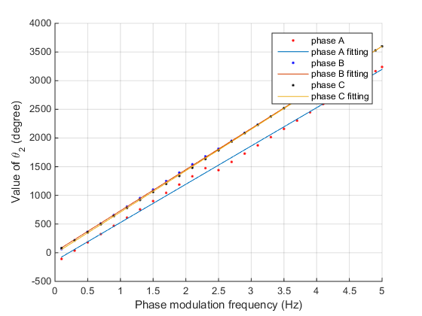

Figure 3‑10 and curve fitting upon different modulation frequency

In conclusion, the magnitude error during the phase modulation can be described using the equations below.

|  |  |  |  |  |  |
| --- | --- | --- | --- | --- | --- |
|  |  |  |  |  |  |
| 0.03064 | -1.9554e-06 | 1.4471e-05 | -3.4445e-06 | 2.5790e-06 | -4.8199e-07 |

|  |  |  |  |  |
| --- | --- | --- | --- | --- |
|  |  |  |  |  |
| -0.015333 | 6.5888e-05 | -9.5856e-05 | 3.2272e-06 | -3.7774e-06 |

.

|  |  |  |  |  |  |
| --- | --- | --- | --- | --- | --- |
|  |  |  |  |  |  |
| 3.1046e-04 | -7.4844e-05 | 1.5616e-04 | -1.9159e-04 | 5.3465e-05 | -9.4319e-07 |

is the magnitude of the input signal, and . is the modulation frequency.

### Phase Error

Phase error of phase modulation is shown in Figure 3‑11.

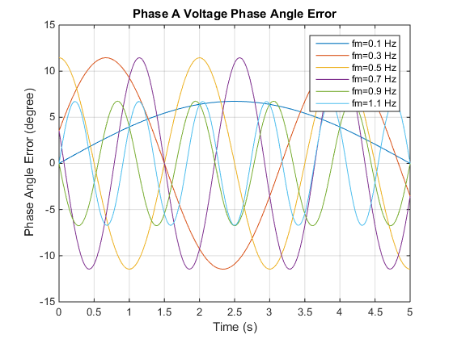

Figure 3‑11 Phase angle error during phase modulation

Unlike the magnitude error, the phase error does not show significant character of multiple-frequency components. Therefore, we can use a simple sinusoidal waveform with the frequency equal to the modulation frequency to represent the phase angle error behavior.

The offset for phase A. For phase B, when and when , seen in Figure 3‑12.

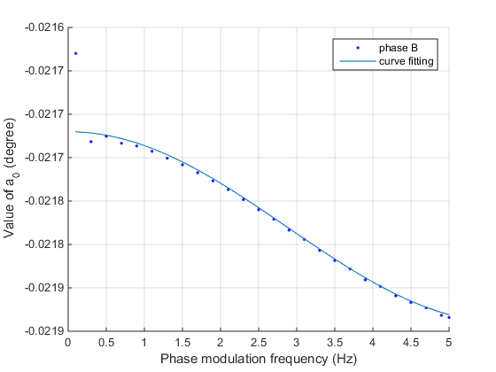

Figure 3‑12 of phase B and the fitting

The of phase C is opposite to of phase B. when and when , seen in Figure 3‑13.

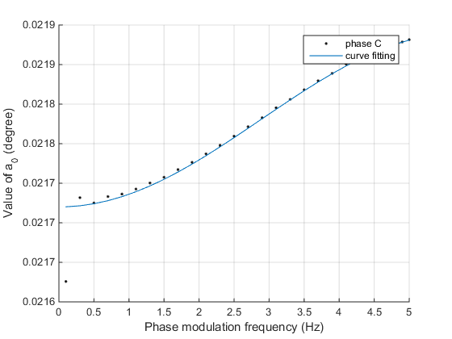

Figure 3‑13 of phase C and the fitting

The magnitude is same for the 3 phases. Due to its periodical characteristic, it can also be described by a sinusoidal function, shown in Figure 3‑14.

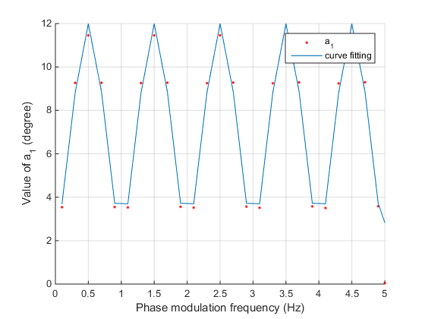

Figure 3‑14 and the fitting

The initial phase angle of 3 phases are the same for each modulation frequency, shown in Figure 3‑15.

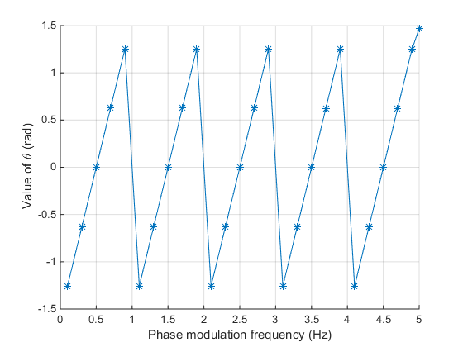

Figure 3‑15 of phase angle error

It can be seen that if we unwrap and add for each of the second group if every 5 points are assigned in as group, the can be described in a linear form shown in Figure 3‑16.

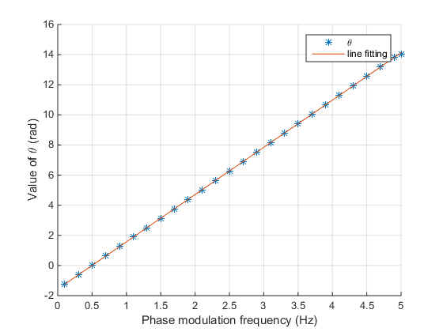

Figure 3‑16 of phase angle error and line fitting

Correspondingly, the magnitude need to multiply at the points where is added to . After changing, is shown in Figure 3‑17.

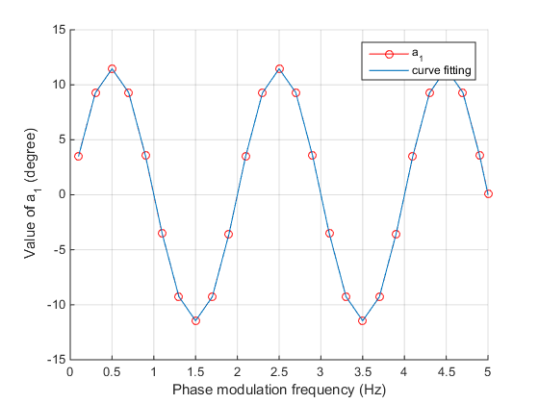

Figure 3‑17 of phase angle error and line fitting

The phase error can therefore be described as

### Frequency Error

Magnitude error of phase modulation is shown in Figure 3‑18.

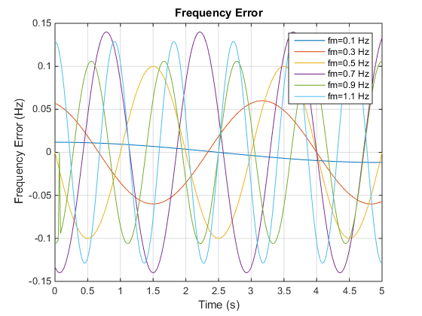

Figure 3‑18 Frequency error during phase modulation

The frequency error includes mainly 2 parts: a fundamental part whose frequency equals to the modulation frequency, and its 3rd harmonic part. It can be described as

The offset .

Similar to the phase error, the is tuned by adding so that it follows a linear behavior shown in Figure 3‑19. The equation is as follows:

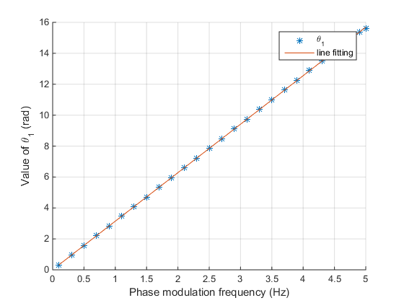

Figure 3‑19 and linear fitting

In this case, the magnitude is plotted in Figure 3‑20.

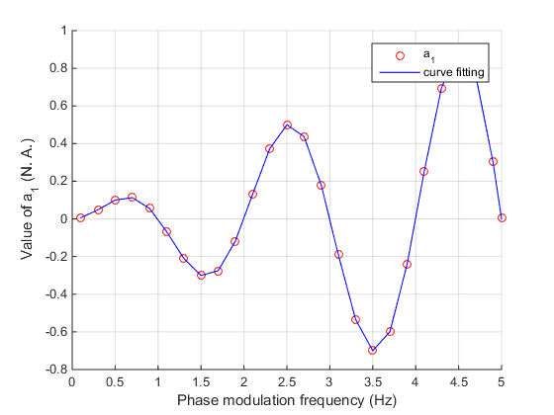

Figure 3‑20 and curve fitting

The magnitude can be represented by the following equation.

The magnitude of the 3rd harmonic, i.e. , is much smaller than and can be ignored for modulation frequencies less or equal to 4.9 Hz. When , and .

In conclusion, the frequency error during phase modulation can be represented as:

When

When

### ROCOF Error

The ROCOF error of different modulation frequency is shown in Figure 3‑21.

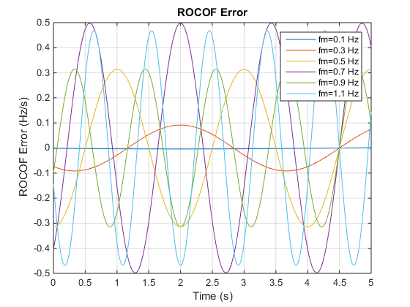

Figure 3‑21 ROCOF error during phase modulation

Similar to the frequency error, the ROCOF error can also be described by the equation below.

The offset .

The magnitude can be represented by the equation below and shown in Figure 3‑22.

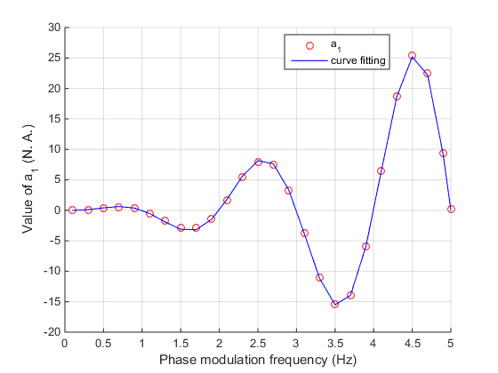

Figure 3‑22 and curve fitting

The initial phase angle can be represented by a linear equation and shown in Figure 3‑23.

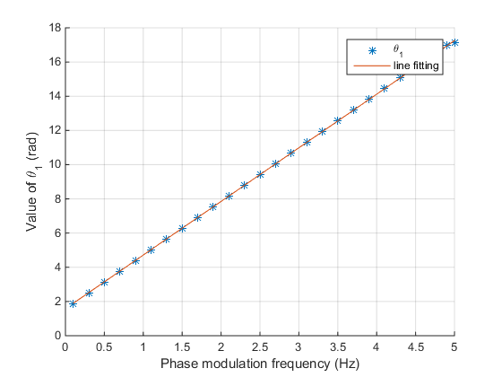

Figure 3‑23 and linear fitting

The magnitude of the 3rd harmonics is much smaller compared to the fundamental part when .

When , and .

In conclusion,

When

When

## Amplitude Modulation

### Magnitude Error

The magnitude errors during amplitude modulation are shown in Figure 3‑1.

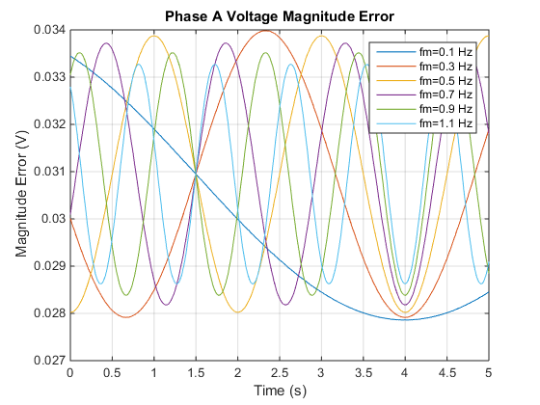

Figure 3‑24 Magnitude error during amplitude modulation

It can be seen from the figure that the magnitude errors are sinusoidal waveforms with frequency equal to the modulation frequency. All magnitude errors of 3 phases are almost the same, and those of both voltage and current are also the same.

The magnitude error can then be described as

Here is the modulation frequency.

The value of magnitude depends on the modulation frequency is shown in Figure 3‑2.

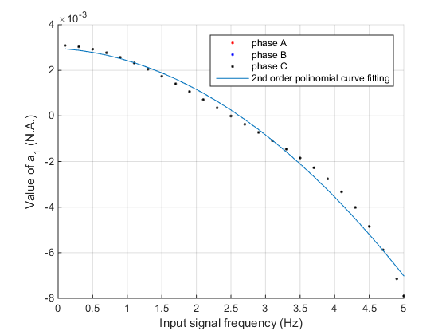

Figure 3‑25 The value of vs. different modulation frequency

The coefficient can be represented by the following polynomial equation.

The offset part is a constant.

The initial phase angle increases linearly with the modulation frequency, and can be represented as

The unit is degree. The unwrapped angle and the fitting curve are showing in Figure 3‑3.

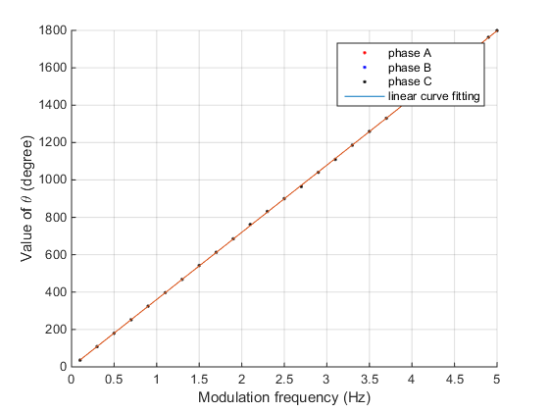

Figure 3‑26 The value of vs. different modulation frequency

In conclusion, the magnitude error of amplitude modulation can be given using the functions below.

### Phase Error

The phase angle errors during amplitude modulation are shown in Figure 3‑2.

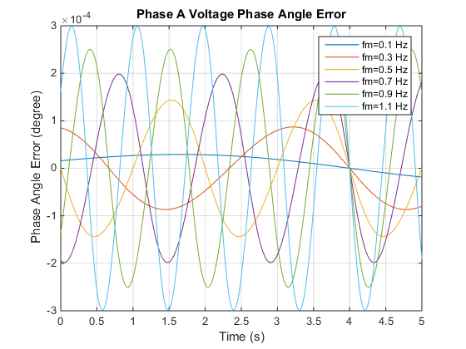

Figure 3‑27 Phase angle error during amplitude modulation

The phase angle errors of voltage and current in corresponding phase are the same. Similar to the magnitude error, the phase error can also be described by a sinusoidal signal with the frequency equal to the corresponding modulation frequency.

Here is the modulation frequency.

The value of magnitude depends on the modulation frequency is shown in Figure 3‑5.

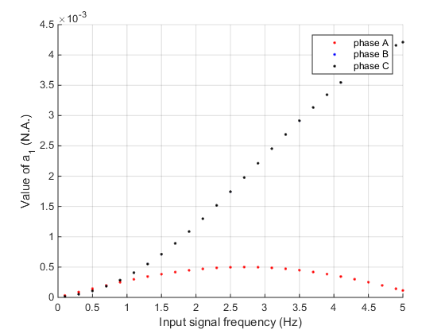

Figure 3‑28 The value of vs. different modulation frequency

It can be seen from the figure that of phase A is different from phase B and phase C, and the latter two parts are the same.

For phase A, can be represented by a sinusoidal curve, shown in Figure 3‑6.

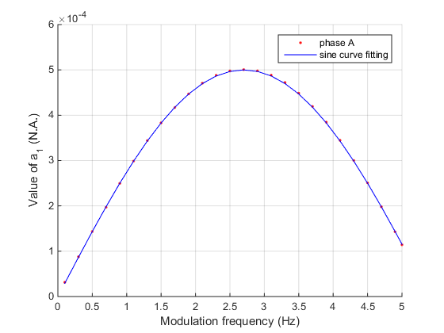

Figure 3‑29 The value of in phase A vs. different modulation frequency

For phase B and C, can also be represented by a sinusoidal curve, shown in Figure 3‑7.

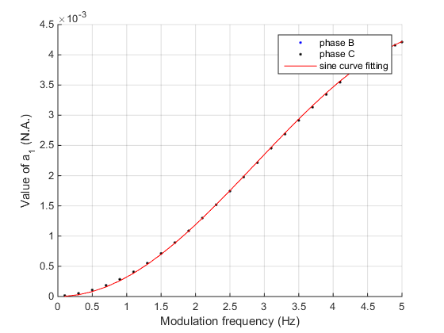

Figure 3‑30 The value of in phase B and C vs. different modulation frequency

The offset part of phase A is a constant.

The values of of phase B and C are shown in Figure 3‑8 and Figure 3‑9.

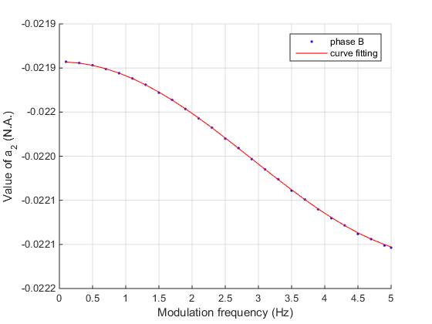

Figure 3‑31 The value of in phase B vs. different modulation frequency

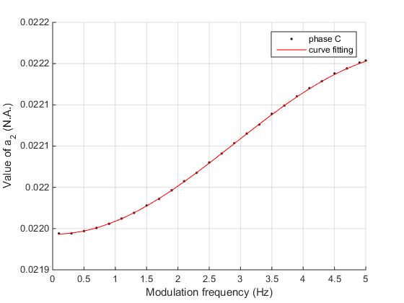

Figure 3‑32 The value of in phase C vs. different modulation frequency

The initial angle can be represented by linear function of the modulation frequency, shown in

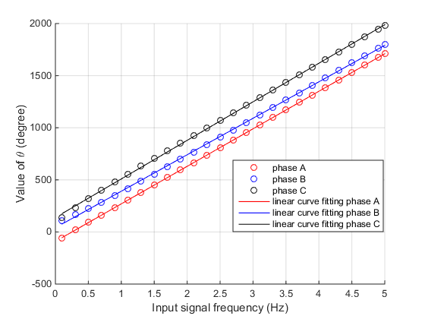

Figure 3‑33 The value of initial phase angle vs. different modulation frequency

The linear expressions of the three phases are given below.

In conclusion, the phase error of the amplitude modulation can be given using the functions below.

### Frequency Error

The frequency errors during amplitude modulation are shown in Figure 3‑5.

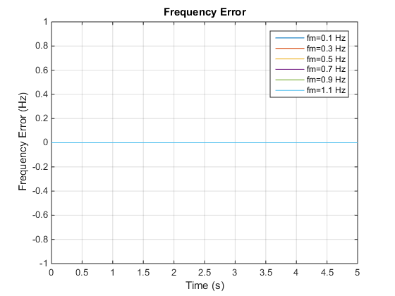

Figure 3‑34 Frequency error during amplitude modulation

They are purely 0.

### ROCOF Error

The ROCOF errors during amplitude modulation are shown in Figure 3‑6.

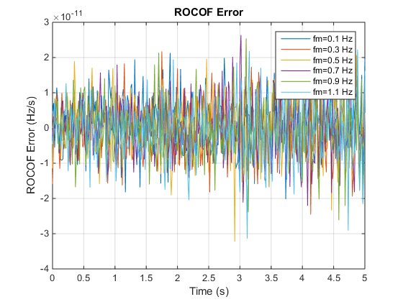

Figure 3‑35 ROCOF error during amplitude modulation

They are within , and can be considered as 0.

# Step Change

## Step Change in Phase

### Magnitude Error

The magnitude errors during amplitude modulation are shown in Figure 3‑1.

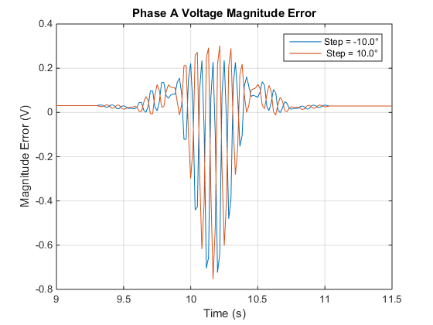

Figure 4‑1 Magnitude error during step change in phase

There are two steady states before and after the step change, and each can be solved by the frequency range algebra equation given in Section 1.1.

Before the step comes, the input signal is a pure 60 Hz signal, and the magnitude error is a constant equal to , and .

There is a period of 103 points deviated from the steady state and each half of them is on one side of the step change time point, before or after. This is due to the algorithm uses a window to estimate the phasor and frequency of each point, and the estimated point utilizes the data before and after it. Therefore, the estimation results of points before the step comes are also influenced.

In the test, in order to reveal the detail of step change response of the PMU, the results of 10 tests are merged to generate the result in Figure 4‑1. The goal is to gain a high resolution of the PMU response without changing the data rate, but by merging the 10 tests. However, since there are phase shifts of the input signal of these 10 tests, their response are influenced by this phase shift and cannot represent the real phase step change. Further simulation reveals that only one result of them is enough to represent the real PMU response. Therefore, the error here is analyzed by using only one result. We decimated 1/10 of the error.



Figure 4‑2 Decimated magnitude error during step change in phase (step = )

It is hard to directly fitting the magnitude error curve. We start from the real and image part of the phasor error.

Both real and image part behaviors like the step change passed a filter. Since the step change can be decomposed into infinite series, those high order components will be suppressed by the filter and algorithm (the estimation algorithm can be considered as a transfer function with finite bandwidth).

To fitting the phase angle error, finite odd orders of the discrete Fourier series are utilized, and passed the filter. Here the maximum finite order is assigned as 500, and the period of the fundamental component is chosen as 16 s according to the observation. The fitting function is given below and the fitting curves are shown in Figure 4‑3.

|  |  |
| --- | --- |
|  |  |
| (a) | (b) |

Figure 4‑3 Real and Image part of magnitude error during step change in phase (step = )

### Phase Error

The frequency error during phase step change is shown in Figure 4‑2. The phase angle error of all the three phases are the same for the same test. Here we use phase A as example for convenience.

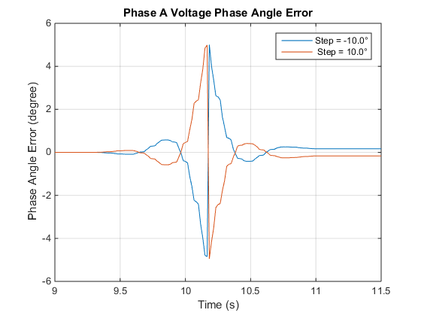

Figure 4‑2 Phase error during step change in phase

The angle error behaviors like the step change passed a filter. Since the step change can be decomposed into infinite series, those high order components will be suppressed by the filter and algorithm (the estimation algorithm can be considered as a transfer function with finite bandwidth).

To fitting the phase angle error, finite odd orders of the discrete Fourier series are utilized, and passed the filter. Here the maximum finite order is assigned as 500, and the period of the fundamental component is chosen as 16 s according to the observation. The fitting function is given below and the fitting curves are shown in Figure 4‑3.

is the amplitude of the step change.

is the phase angle of the steady state. is the real frequency.

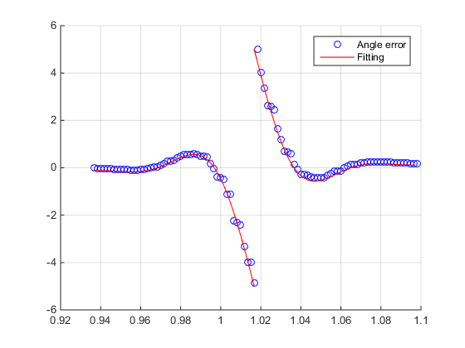

Figure 4‑3 Phase error and fitting during step change in phase

### Frequency Error

The frequency error during phase step change is shown in Figure 4‑3. Notice that here we use the steady state frequency as the true frequency, while the ideal frequency value has an infinite impulse at the phase step change point.

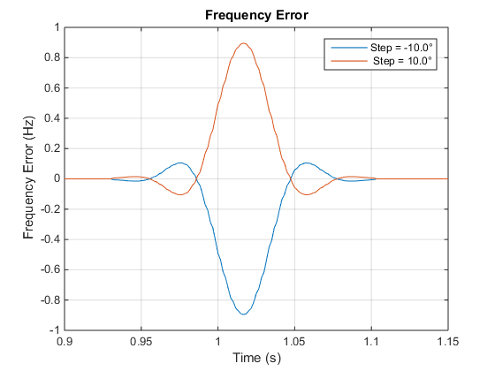

Figure 4‑4 Frequency error during step change in phase

The behavior of the frequency error is similar to the impulse response of the FIR filter. This is because the true frequency is a constant value during the steady state, and it is an infinite impulse at the step change point. Therefore, the behavior is similar to the impulse response of the FIR filter. Both the error and the filter response were drawn in Figure 4‑4. The impulse response of the FIR filter is tuned to fit the frequency error.

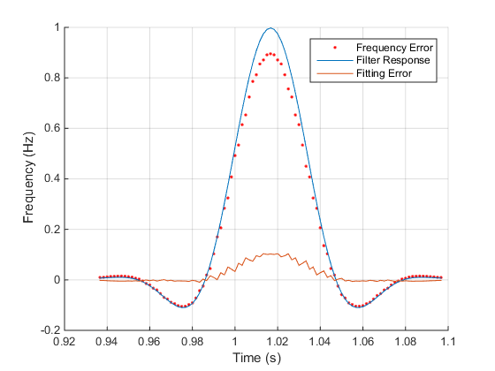

Figure 4‑5 Frequency error during step change in phase and the impulse response of the FIR filter

It can be seen from Figure 4‑5 that the left and right sides fit well, but the middle part is not. Hence a coefficient is multiplied to the fitting.

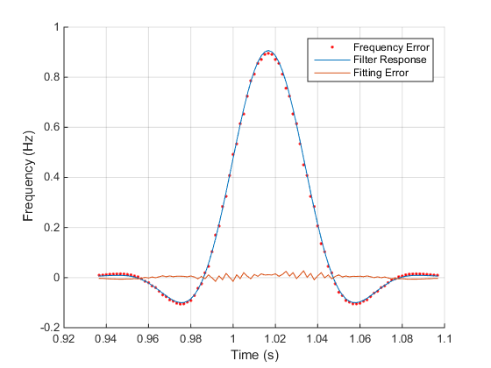

Figure 4‑6 Frequency error during step change in phase and the impulse response of the FIR filter after tune the filter response

The fitting now is better.

The impulse response of the filter is described using the following equations.

Here is tuned to 13, , , and the window function is a Hamming window.

It can be seen that there is still some minor error. This may be caused by the spectrum leakage since there are many high frequency components during the step change.

### ROCOF Error

The ROCOF error during step change in phase is shown in Figure 4‑6.

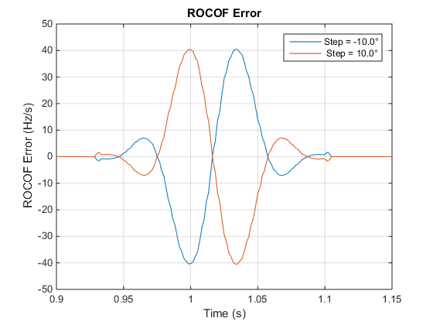

Figure 4‑7 ROCOF error during step change in phase

It can be seen that the error of ROCOF is the differentiation of the frequency error.

Using the derivative function of the impulse response of the FIR filter to fit the ROCOF error. The function can be written as follows and shown in Figure 4‑7.

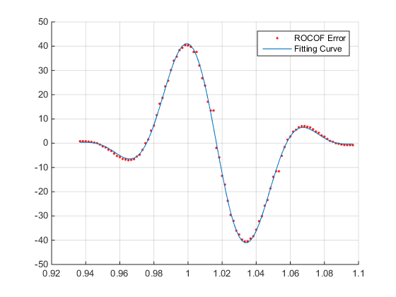

Figure 4‑8 ROCOF error and the fitting curve during step change in phase

## Step Change in Amplitude

The true phase looks strange. Should be steady but seems not. Need to discuss.

### Magnitude Error

The magnitude error during step change in phase is shown in Figure 4‑9.

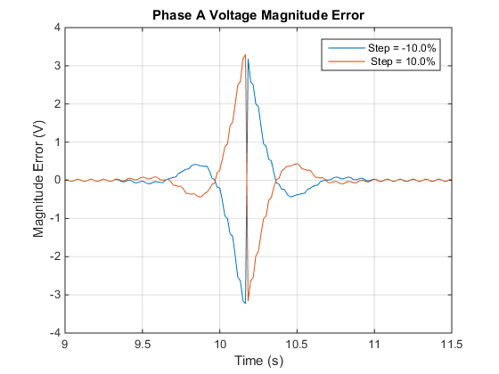

Figure 4‑9 Magnitude error during step change in amplitude

It is similar to the phase error during step change in phase. Therefore, the same method can be used to fitting the error.

is the phase angle of the steady state. is the real frequency.

The fitting result is shown in Figure 4‑10.

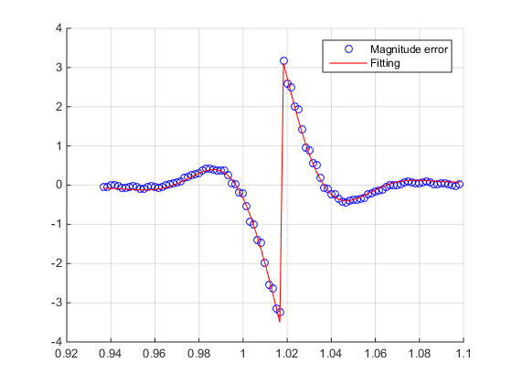

Figure 4‑10 Magnitude error and fitting during step change in phase

Notice that in the steady state the measured data has fluctuation. This is because the measured data is composed from 10 sub-test results. (Not each group are aligned well, so they have a 10 points term period).

### Phase Error

Since the test result is a combination of 10 sub-tests, and they are not aligned quite well, some compensations are implemented. The detailed demonstration can be found in Appendix C.

After compensation, the phase error is shown in Figure 4‑11.

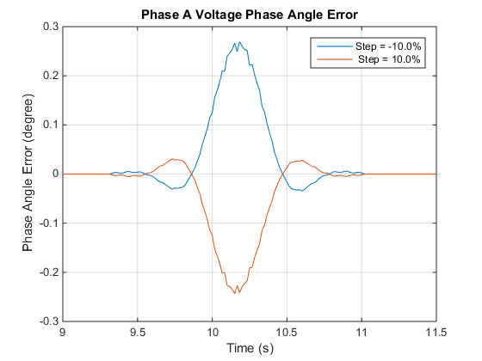

Figure 4‑11 Phase error during amplitude step change

It is similar to the frequency error during phase step change. Therefore, impulse response of the FIR filter is used to describe this phase error, the equations are shown below.

Here is tuned to 13.3, , , and the window function is a Hamming window.

It can be seen that there is still some minor error. This may be caused by 1) the spectrum leakage since there are many high frequency components during the step change, 2) the 10 sub-test composition.

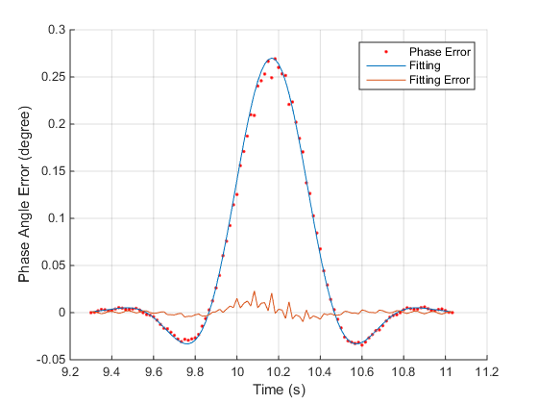

Figure 4‑12 Phase error and fitting during step change in amplitude

### Frequency Error

The measured frequency equals to the true frequency and there is no error.

### ROCOF Error

The ROCOF error during step change in phase is shown in Figure 4‑10.

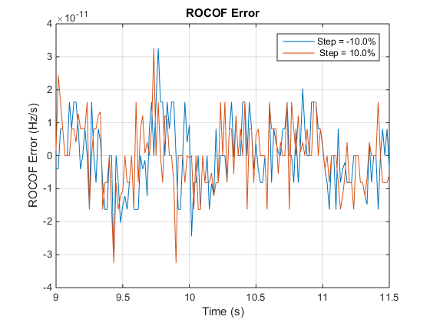

Figure 4‑13 ROCOF error during step change in amplitude

It can be seen that the ROCOF error is within and thus negligible.

1. Time Round Off Error

The Time Round off Error is caused by the finite significant bit of the calculator. Take the example of the case where the reporting rate is 60 Hz. In this case, the real PMU estimates exactly (we assume) 60 times per second. However, to give the true value to the phasor, frequency, etc., a program is used, and the time input to it is truncated. For example, the time of the 2nd point is 1/60 s, i.e. 0.016,666,6… . The program, however, cannot accept a decimal with infinite bits; therefore, it is truncated to 1 µs, i.e. 0.016,666 s. The true phasor and frequency of 1/60 s is than calculated on the time of 0.016,666 s, which introduced an error.

|  |  |  |  |  |  |  |
| --- | --- | --- | --- | --- | --- | --- |
| Fraction of second | 0 | 0.016,666,6… s | 0.033,333,3… s | 0.050,000 s | 0.066,666,6… s | 0.083,333,3… s |
| Truncated time | 0 | 0.016,666 s | 0.033,333 s | 0.050,000 s | 0.066,666 s | 0.083,333 s |
| Time error | 0 | +0.666,6... µs | +0.333,3… µs | 0 | +0.666,6... µs | +0.333,3… µs |
| Im error at 60 Hz | 0 | 0.01759292 | 0.008796459 | 0 | 0.01759292 | 0.008796459 |
| Phase angle error at 60 Hz (degree) | 0 | 0.0144 | 0.0072 | 0 | 0.0144 | 0.0072 |

|  |  |
| --- | --- |
| Fraction of second | 0.016,666,6… s |
| Round off time | 0.016,667 s |
| Time error | -0.333,3... µs |
| Phase error at 60 Hz | -0.008796459 |
| Phase angle error at 60 Hz (degree) | -0.0072 |

The phase angle error then can be calculated by

If it is implementing frequency ramping, there will also be frequency error.

1. Filter

A family of digital filters that is commonly used in PMU design is the FIR filter. FIR filters are implemented by convolving the sampled signal segment with a windowed version of the impulse response of the desired filter. Windowing is used because many filter impulse responses are infinite and the sampled signal segment is finite.

A PMU designer has many choices of filter impulse responses and windowing functions. There are trade-offs between these choices that the designer may make or may be left to the user of the PMU if the designer allows the user to choose between various options.

* 1. Sinc Functions

The Sinc function is a common choice of impulse response for PMU design:

|  |  |
| --- | --- |
|  | ( 2 ) |

For a low-pass filter, the reference frequency and the sample rate determines the filter “coefficients”.

|  |  |
| --- | --- |
|  | ( 3 ) |

*Where:*

*Ffr = Reference Frequency*

*Fsampling = Sample rate of the sampled signal segment*

*n = signed sample number (where 0 is the center of the sampled segment)*

A complex sinusoidal sampled signal segment consisting of N samples can be represented by

|  |  |
| --- | --- |
|  | ( 4 ) |

*Where:*

*ϕ = the initial phase of the signal*

*n = sample number in the segment ranging from -N/2 to N/2*

*N is the size of the sampled segment*

*ω0 is the signal angular frequency scaled by the sample rate and N:*

|  |  |
| --- | --- |
|  | ( 5 ) |

The complex frequency response will be:

|  |  |
| --- | --- |
|  | ( 6 ) |

For any arbitrary angular frequency ω.

* 1. Windowing

Convolving a signal with an infinitely long Sinc function would theoretically produce a “brick wall” filter, that is all frequency components below the stop frequency would be unattenuated and all components above the stop frequency would be infinitely attenuated. The phase error is due to a constant delay in the filter (as it is for all FIR filters), however for the infinitely long Sinc Filter, the delay is infinite.

So any practical Sinc filter would need to be “windowed”. Windowing multiplies a segment of the Sinc function by a finite length “window function” to create a finite length set of filter parameters. Windowing the sinc function has two effects on the filter:

1. The filter roll-off (the rate (slope) of attenuation per frequency outside the pass-band) is no longer infinite but now has some slope)
2. The pass-band and/or stop band will have “ripple”, which is signal attenuation and gain over the frequency spectrum.
3. The amount of attenuation in the stop band is determined by the windowing function.
4. The length of the window (which is the same as the number of samples in the sampled signal segment) determines the bandwidth of the transition (filter roll off). Increasing the window length reduces the transition bandwidth (increases the slope of the filter roll off). While this is desirable, there are specified limits to the ‘response time” of a PMU.
   * 1. Rectangular window

The simplest windowing function is a rectangular window centered on the Sinc function. This has the effect of truncating the sinc function and causes a significant amount of ripple both in the pass-band and the stop band of the filter output. Many windowing functions have been found which reduce pass-band and/or stop band ripple, and increase or decrease frequency roll-off slope. Windowing functions scale the filter parameters in such a way that they continuously transition towards 0 at the beginning and end of the segment of sampled signal.

|  |  |
| --- | --- |
|  | ( 7 ) |

* + 1. Hamming Window

A very popular windowing function because it is relatively easy to implement and yields flat in-band ripple and 53 dB of stopband attenuation.

|  |  |
| --- | --- |
|  | ( 8 ) |

The Hamming window function is used by the IEEE C37.118.1 PMU Signal Processing Model annex (which I remind the reader is not the required, recommend or even the preferred PMU algorithm.)

There are many other window functions available and they are well documented in the literature so this paper will not show any more examples.

* 1. Frequency Response of the Windowed Sinc Filter

The frequency response for the windowed Sinc filter becomes:

|  |  |
| --- | --- |
|  | ( 9 ) |

For any arbitrary angular frequency ω